**DSD ASSIGNMENT -4**

Sign Adder and 16:1 Mux

C.P.Sindhu(PES1UG21EC071) , Amogh S. Rao(PES1UG21EC033), Akshat VA(PES1UG21EC028)

1. Sign Adder

Code:

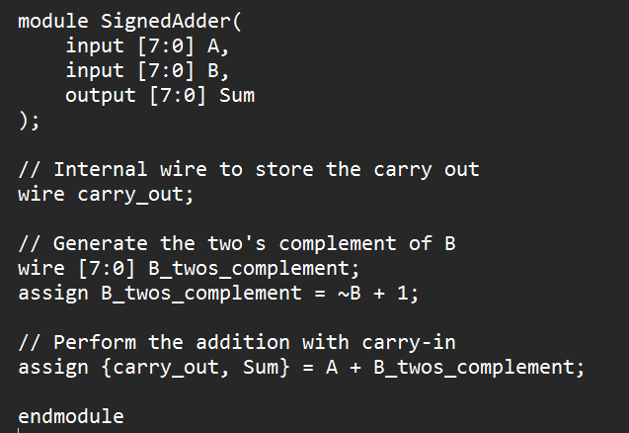

Synthesis:

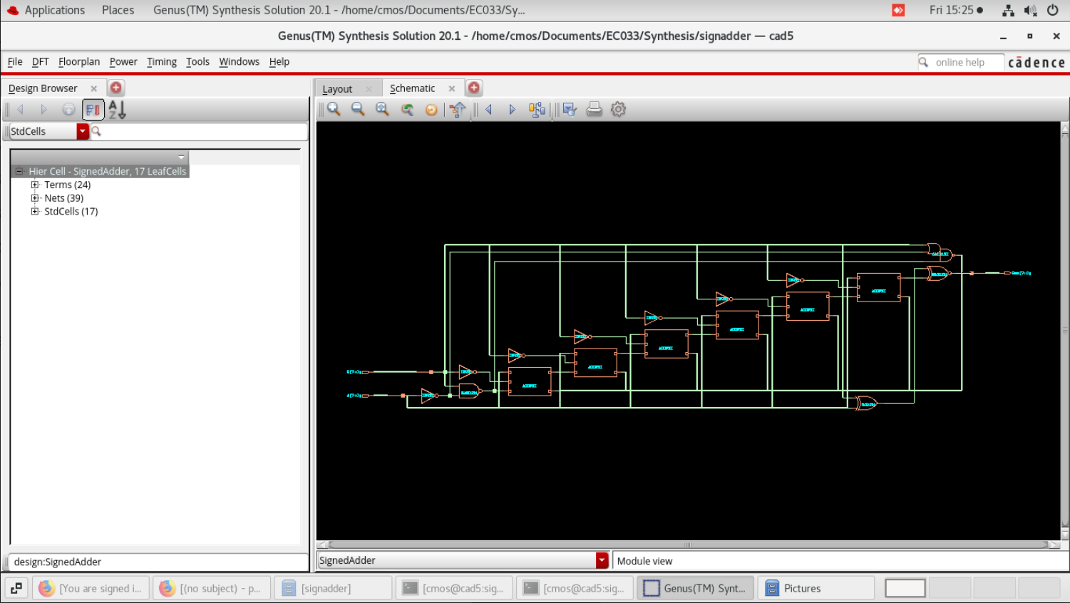

Rpt Screenshots:

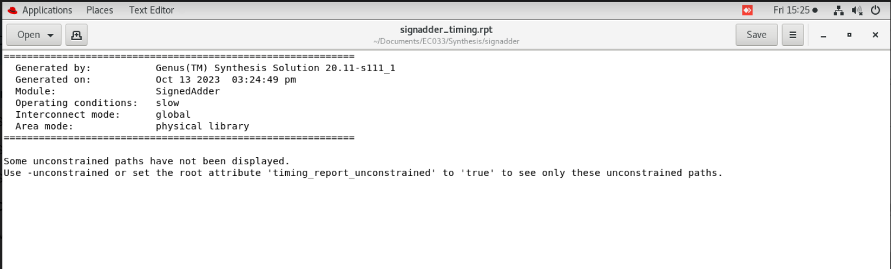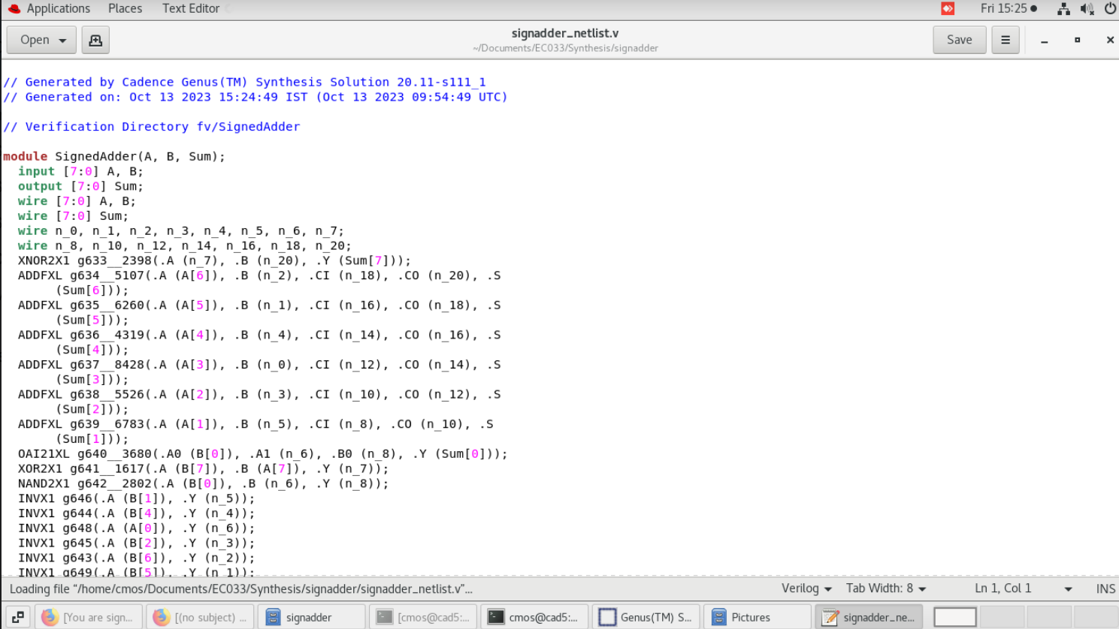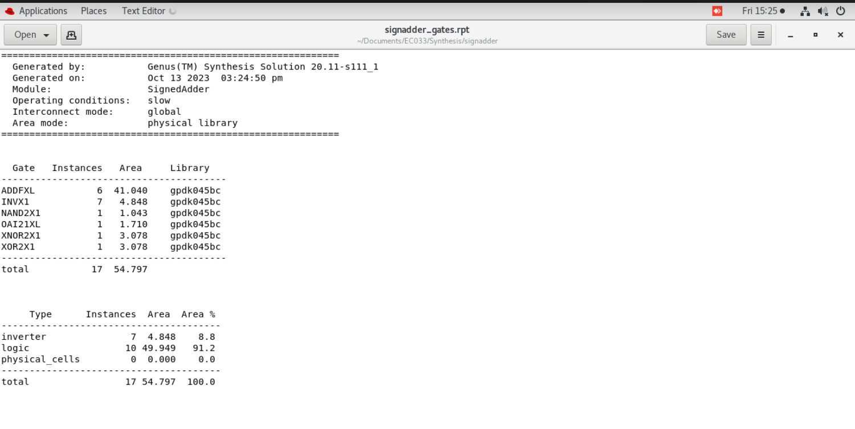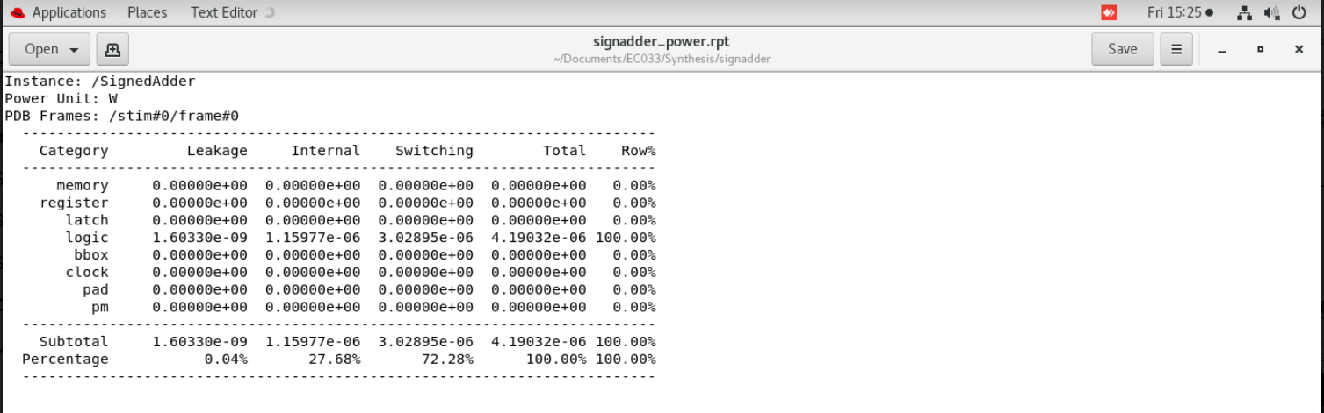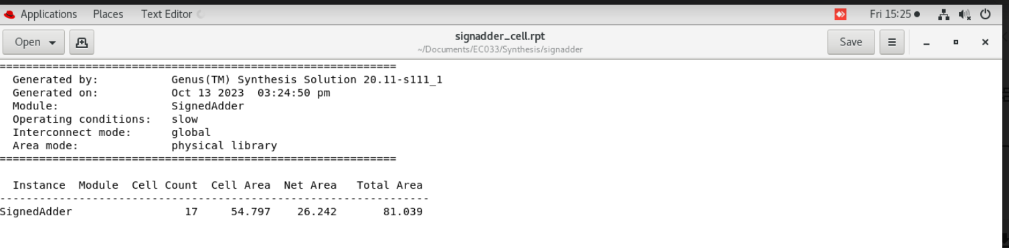

1. 16:1 Mux

Code:

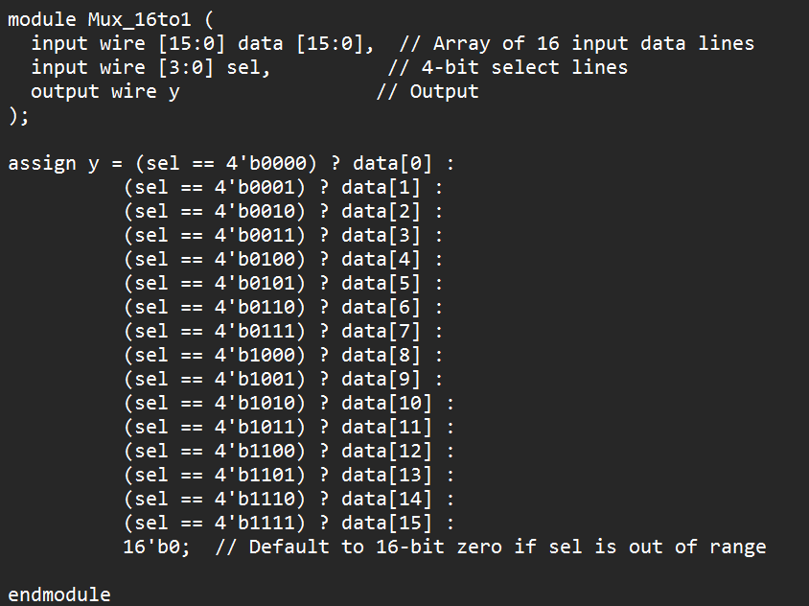

Synthesis:

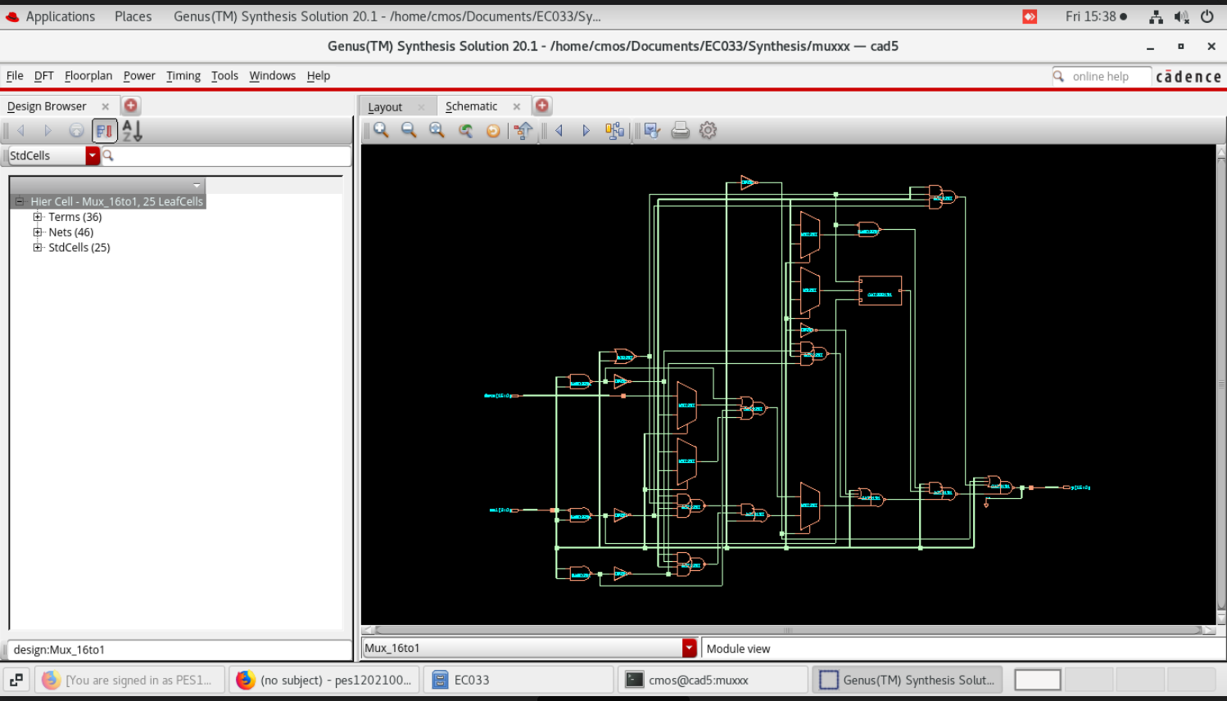

Rpt Screenshots:

